Beautiful lot, fully fenced back yard.
2 level Raised Rambler with 3 Bedroom, 2 full bath.
Location Glendale Road, Woodbridge, VA 22193.

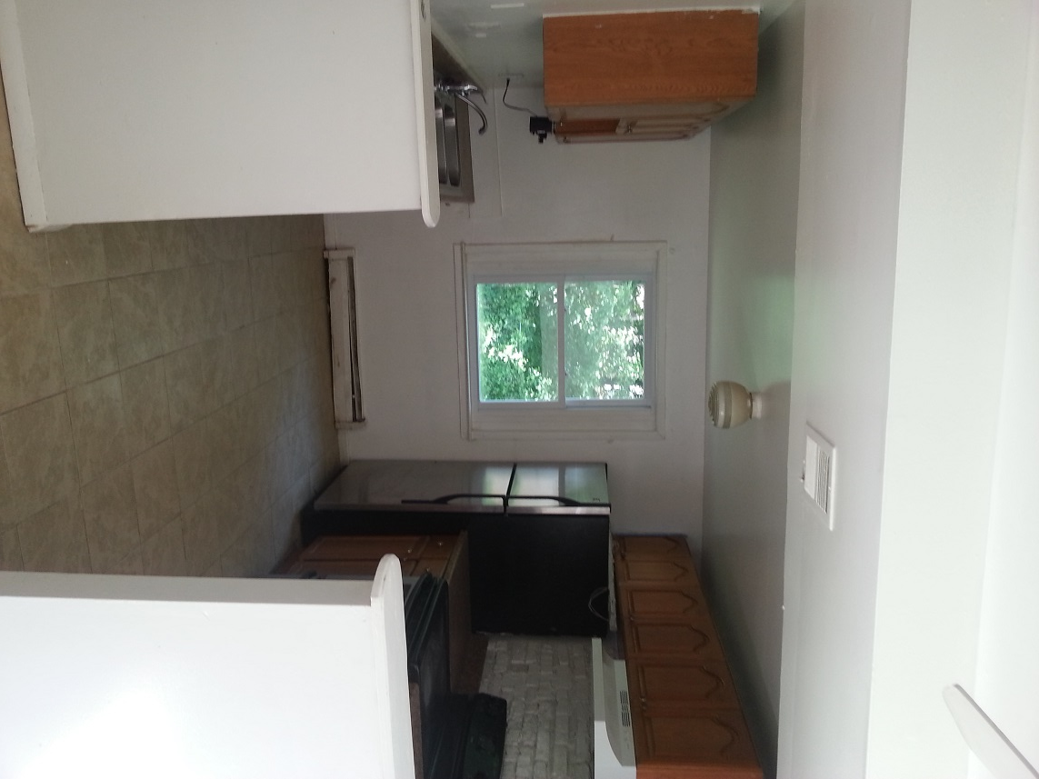

Kitchen with marble top, Kitchen Electric Range, Refrigerator
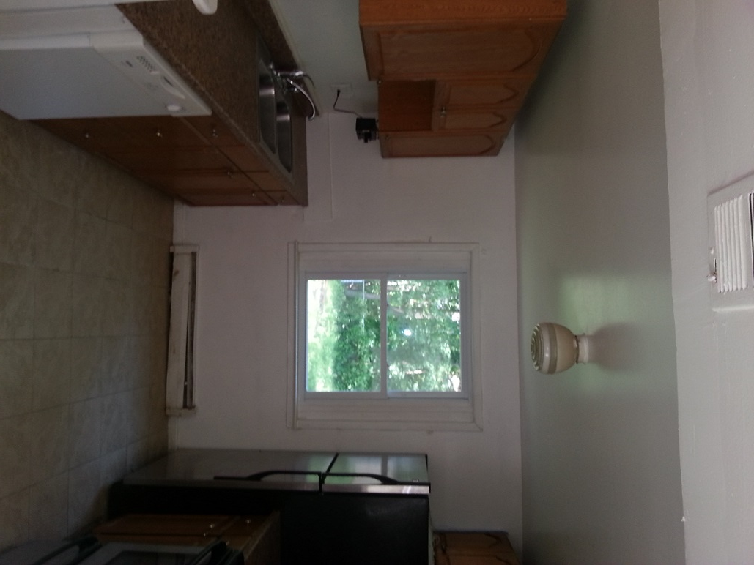
kitchen with dish washer
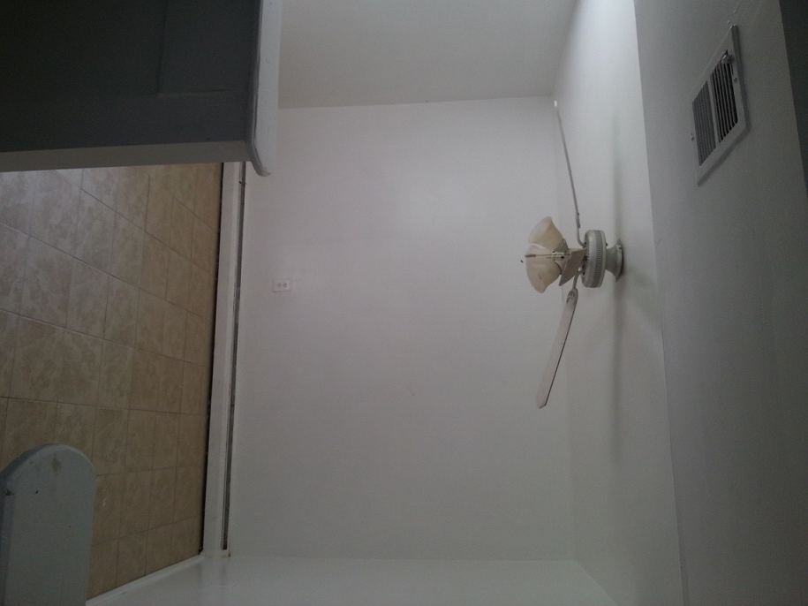

Tiled Dining Room

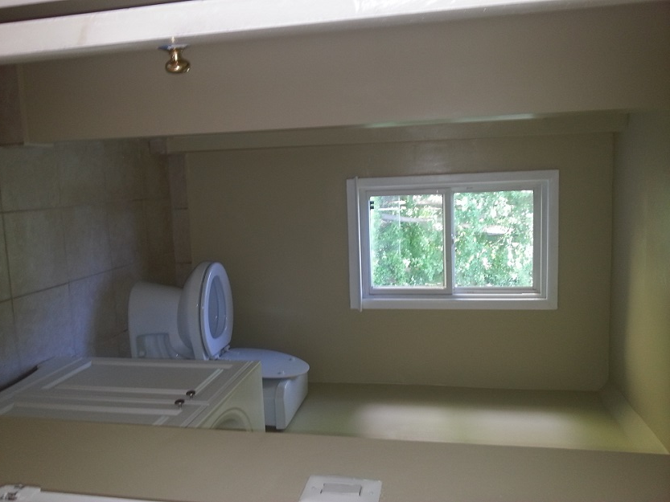

Full bath on lower level

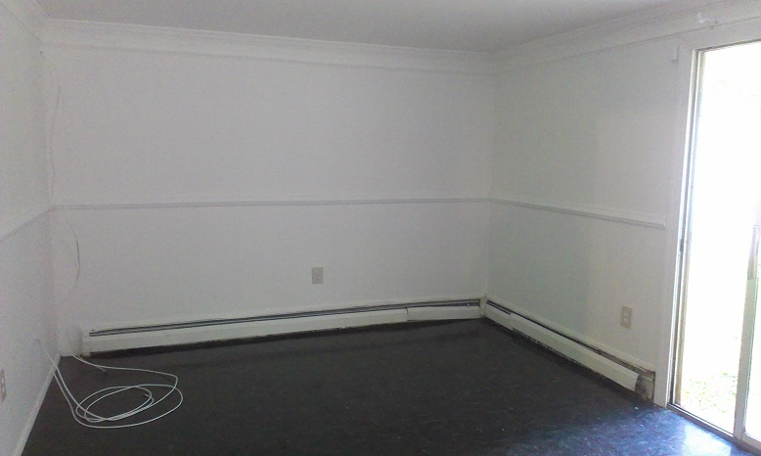
Lower level Recreation Area opens to yard

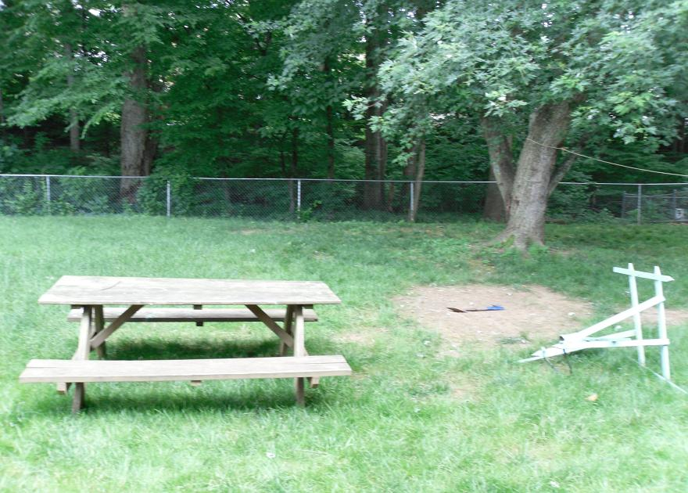

Fenced Yard facing out from Recreation area

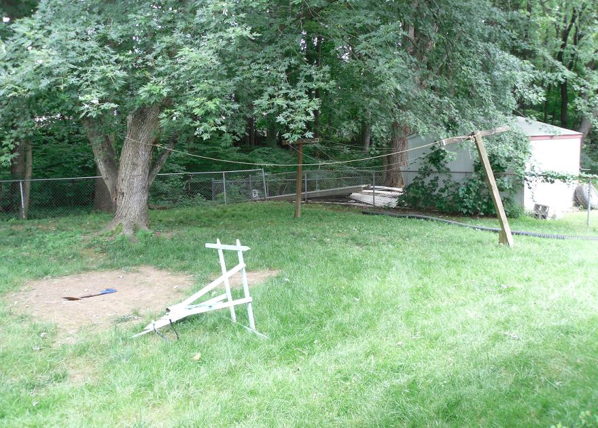

Fenced Yard facing out from Recreation area

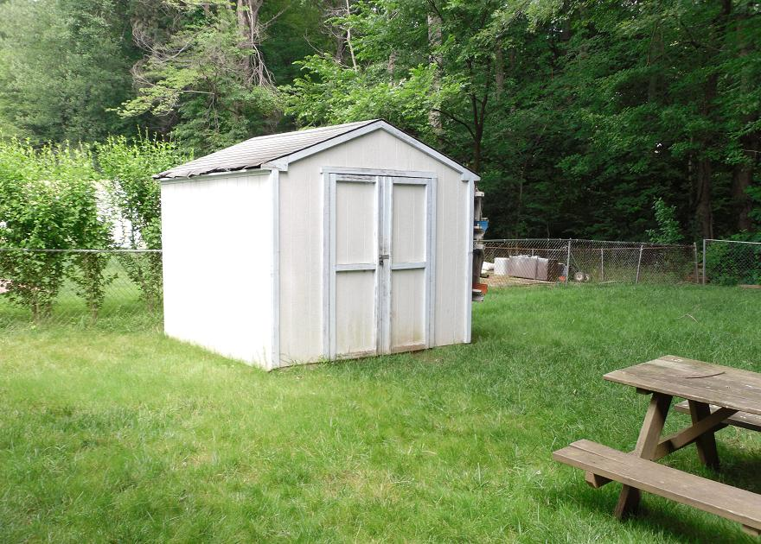

Shed

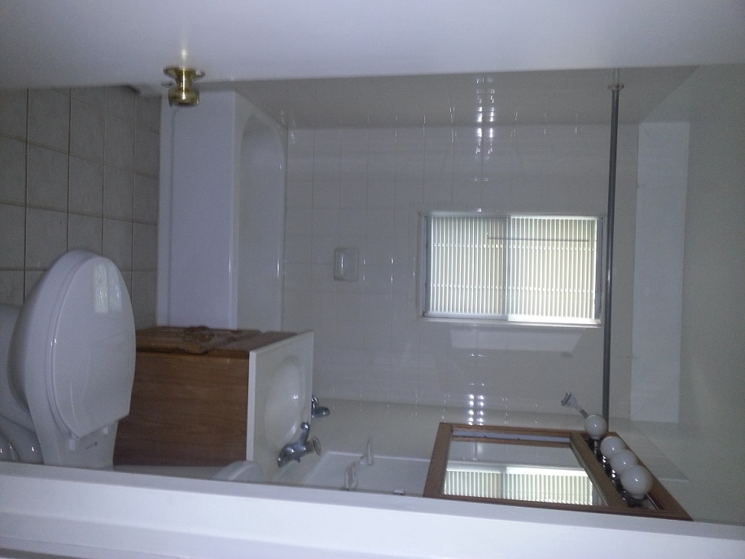
Full bath on top level

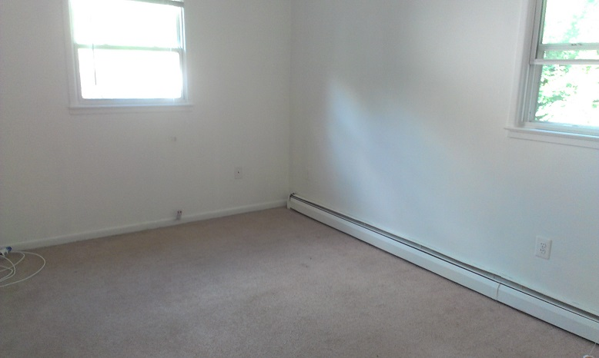
Bedroom 1

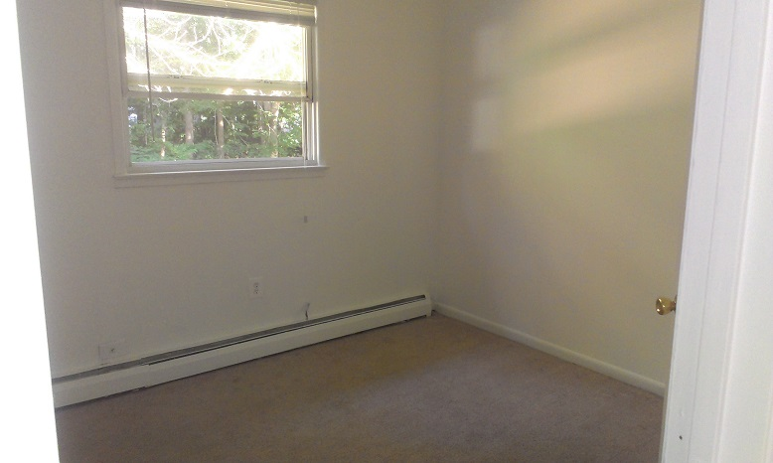

Bedroom 1

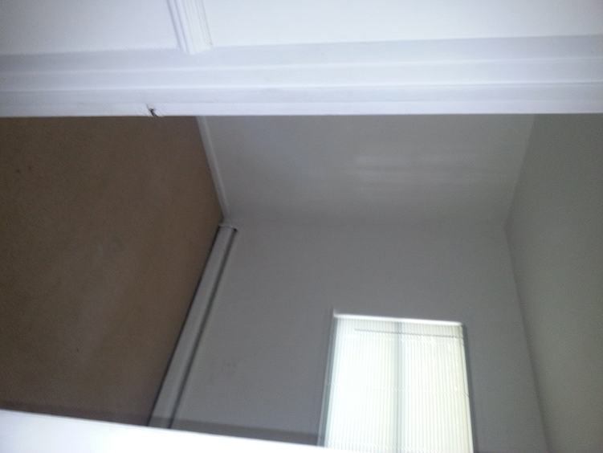
Bedroom2

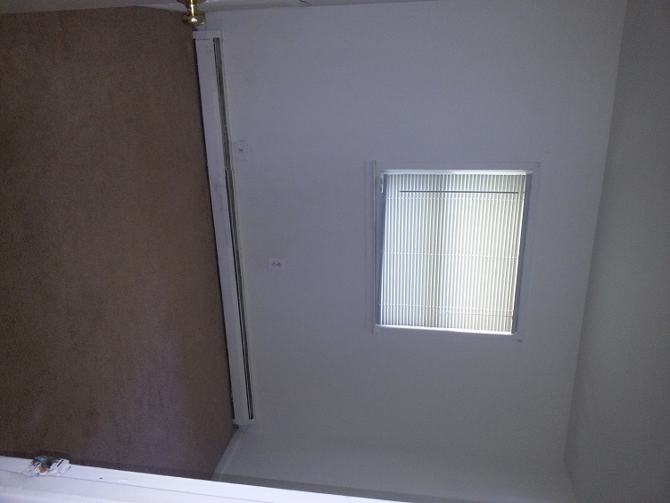
Bedroom3

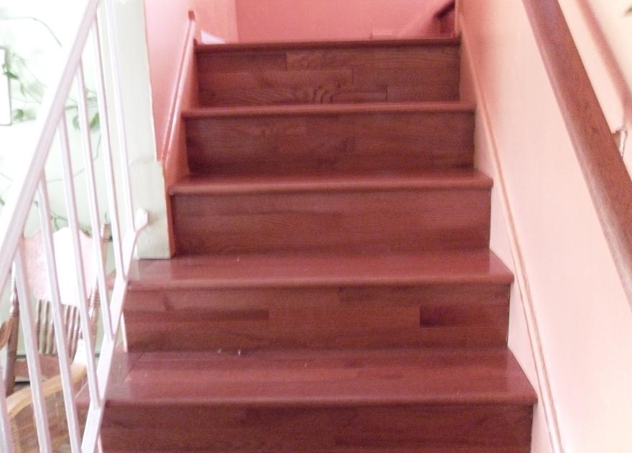

Steps to Main Level

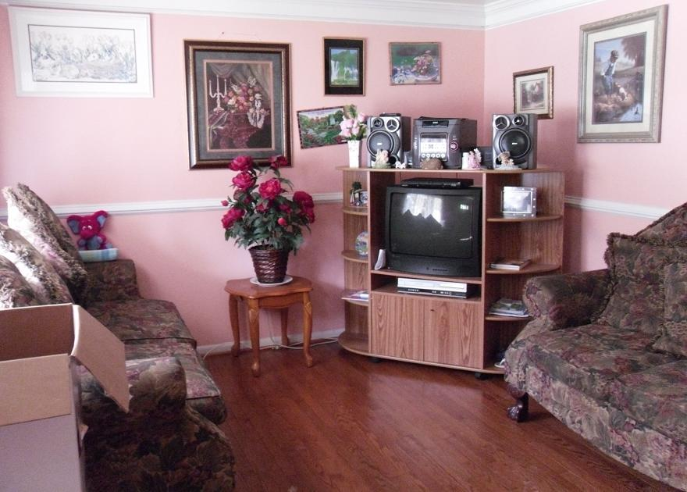

Living Room from entrance

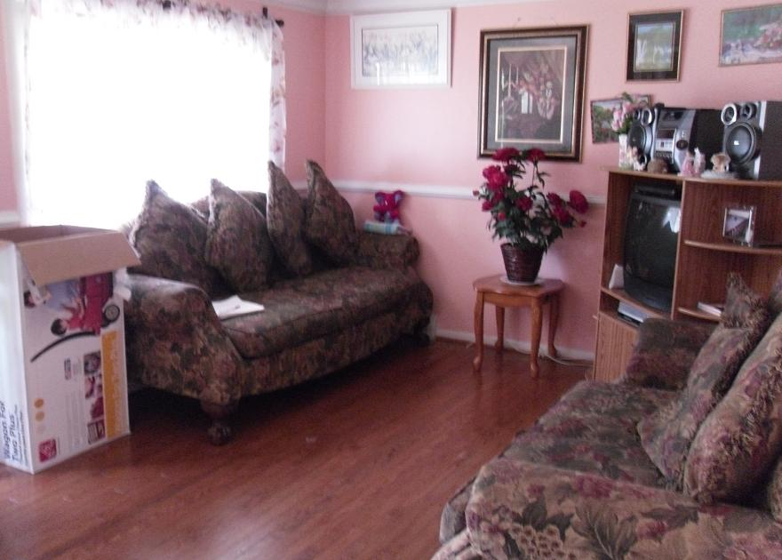

Living room view from corridor
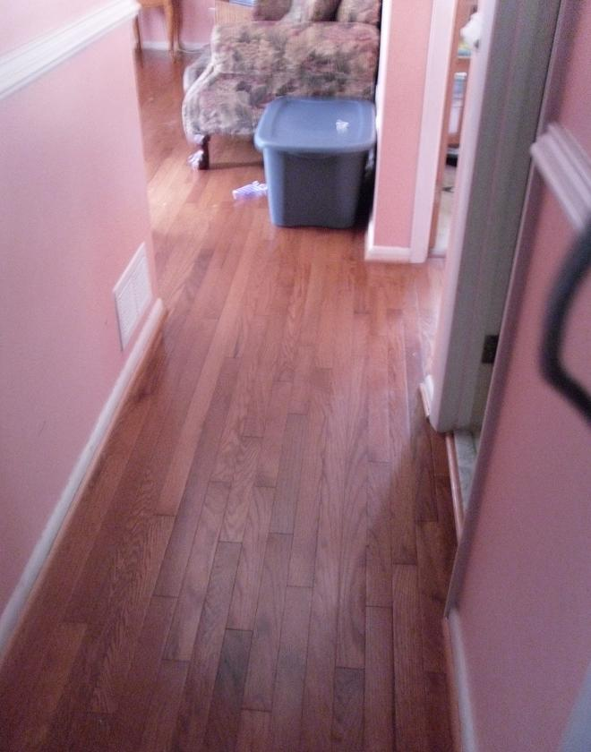

Living room view from corridor

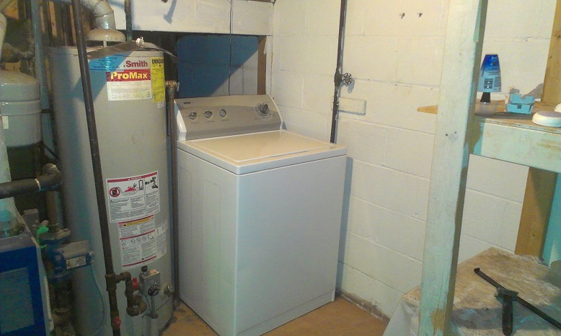

In utility room – water heater and HVAC unit

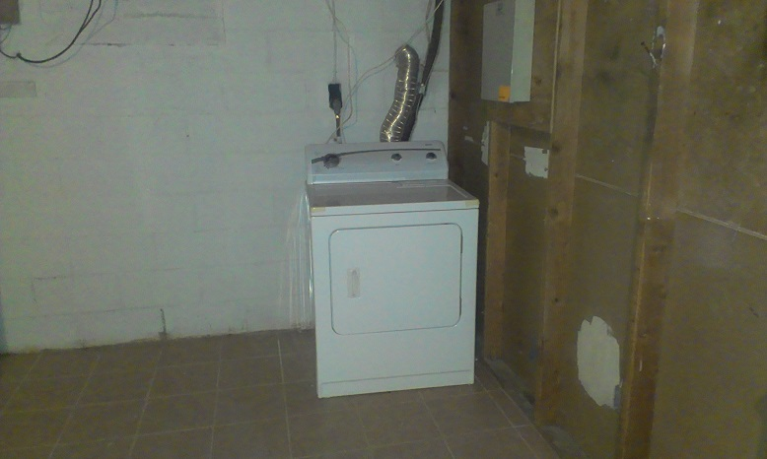

Drier

