Beautiful lot, fully fenced back yard.
2 level townhouse with 3 Bedroom, 2 full bath, and 1 half bath.
Location Candlewood Court, Woodbridge, VA 22191.
Property is available to view in person and for rent immediately.

Kitchen

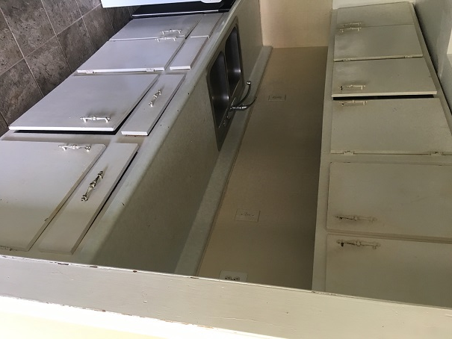

Corridor to dining room

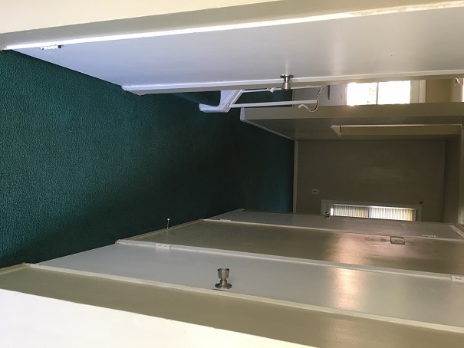

Living room

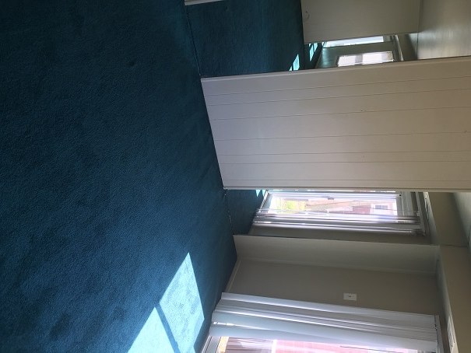

Half bath on main level, washer, drier

Steps to upper level

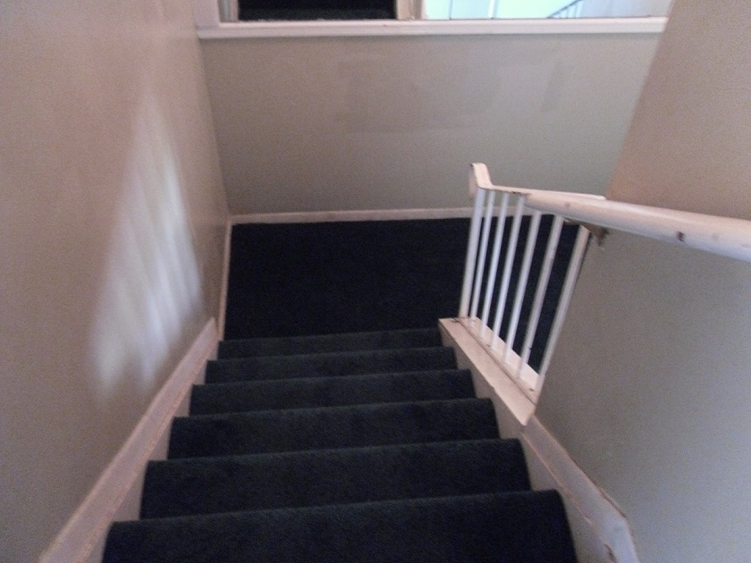

Bedroom1

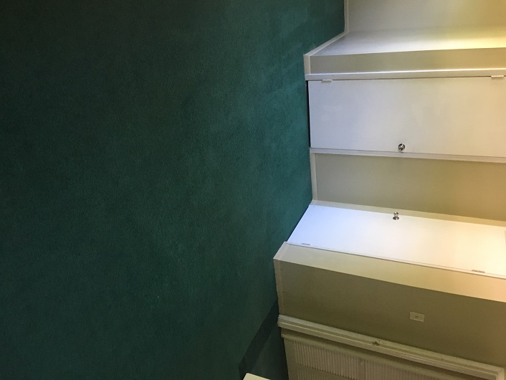

Master Bedroom bathroom

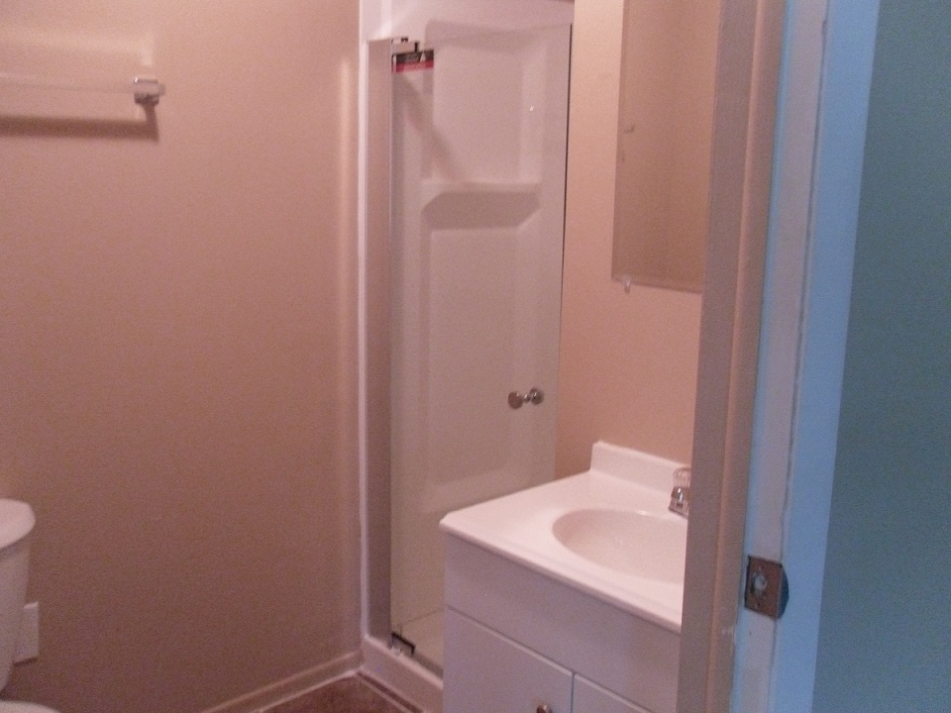

Bedroom2

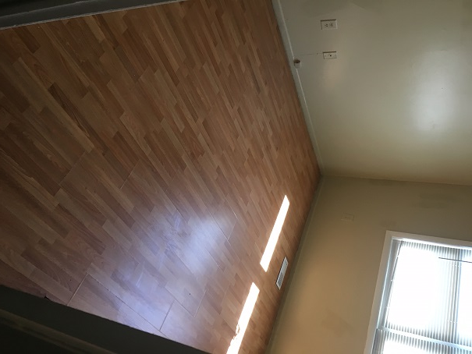

Bedroom3

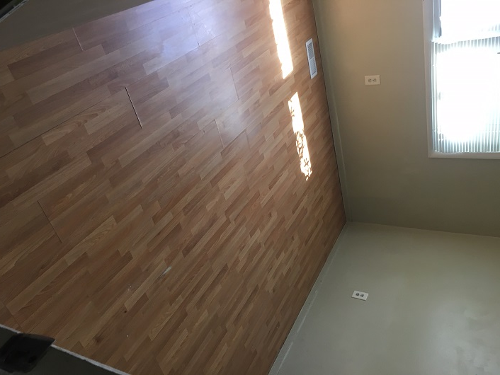

Full bath on upper level



